Full Wave Bridge Rectifier

Introduction:

What is a Bridge Rectifier?
A bridge rectifier is an arrangement of four diodes in a bridge circuit configuration which provides the same output polarity for either input polarity. It is used for converting an alternating current (AC) input into a direct current (DC) output.

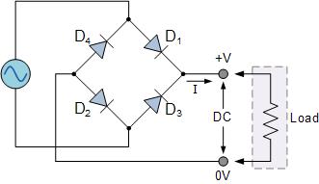
Full Wave Bridge Rectifier

The four diodes labeled D₁ to D₄ are arranged in “series pairs” with only two diodes conducting current during each half cycle.
Working:

1) The Positive Half-Cycle:
During the positive half cycle of the supply, diodes D1 and D2 conduct in series while diodes D3 and D4 are reverse biased and the current flows through the load as shown below.
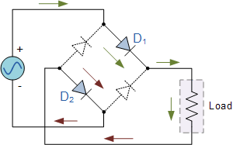
Positive Half Cycle

2) The Negative Half-Cycle:
During the negative half cycle of the supply, diodes D3 and D4 conduct in series, but diodes D1 and D2 switch “OFF” as they are now reverse biased. The current is flowing through the load in the same direction as before.
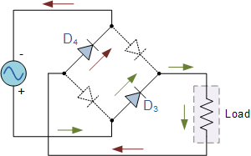
Negative Half Cycle
Conclusion:
As the current flowing through the load is unidirectional, so the voltage developed across the load is also unidirectional. Hence the AC voltage signal has been rectified to a uni-directional DC voltage signal.

Circuit Diagram of Full Wave Bridge Rectifier:

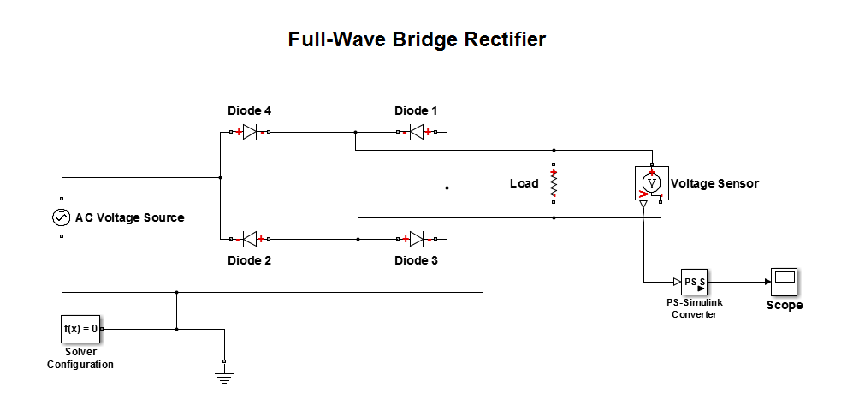
Design on MATLAB

Design Detail:

- AC Voltage Source used to generate Sinusoidal wave.
- Four diodes for rectification purposes
- During Positive Half Cycle, diode 4 and 3 would be on.
- During Negative Half Cycle, diode 2 and 1 would be on.
- A load resistance of any value.
- Then a voltage sensor to sense the voltage.
- After that a PS-Simulink Convertor which converts the input Physical Signal to a unit less Simulink output signal.
- After that Scope is used to obtain the output waveform. (Graph)

